**Lab Tasks**

**By**

**FARWA RASHID (45945)**

**Subject**: Operating System

**( LAB 10 )**

**Date**: 29/10/2024

**BSCS SEMESTER – 5**

**RIPHAH INTERNATIONAL UNIVERSITY**

**ISLAMABAD**

**Task 01: How do you create a basic for loop in a shell script to iterate over a list of numbers from 1 to 5?**

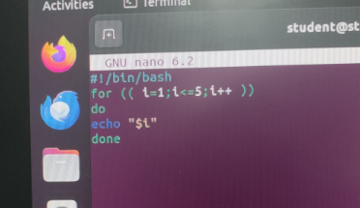

**Q2. What is the syntax for a while loop that counts from 1 to 10 and prints each number?**

**Q3. How would you write a nested loop in shell scripting to print a multiplication table from 1 to 3?**

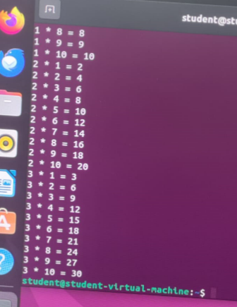

**Q4: Write a for-in loop that iterates over the items in an array named fruits containing apple, banana, and cherry.**

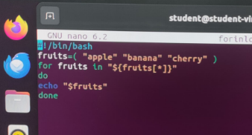

Q5: Write a while loop that reads user input until the user types "exit".

